|  |  |
| --- | --- |
| **GAT150 – Introduction to Game Programming** |  |

***BOX2D PHYSICS***

***OVERVIEW***

In this assignment you will create the library for our physics.

***GRADING***

This assignment is worth 25 points. To receive full credit for this assignment, you will need to add the Box2D physics library to our engine. Submit a screenshot of a Box2D demo running in Visual Studio.

***INSTRUCTIONS***

# Download Box2D

* <https://box2d.org/>
* Click on the GitHub icon
* On GitHub click on the box2d repository
* Download the code (Download ZIP)

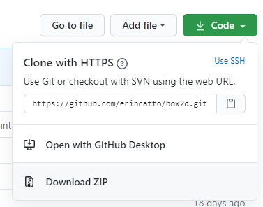

* Extract the box2d-master.zip file

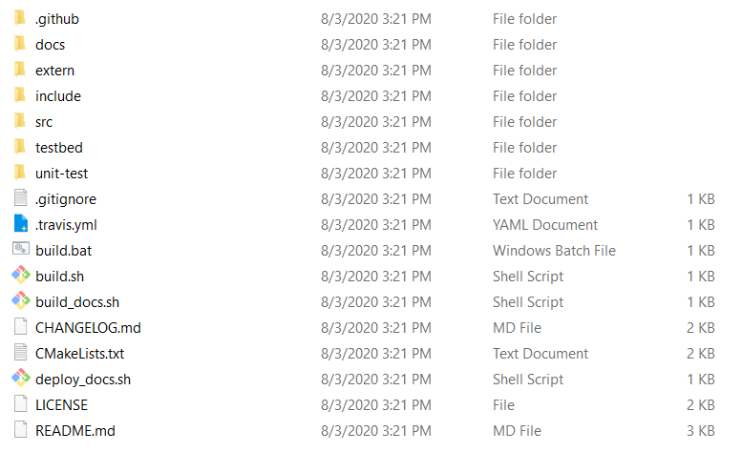

# Build Box2D

* Follow the directions in the Building section of the page
  + Look for this section

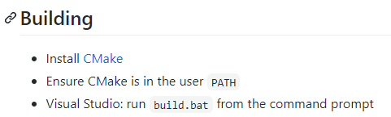

* Install CMake
  + <https://cmake.org/>
    - Go to the Download page
    - Download the Windows win64-x64 Installer



* + Run the installer

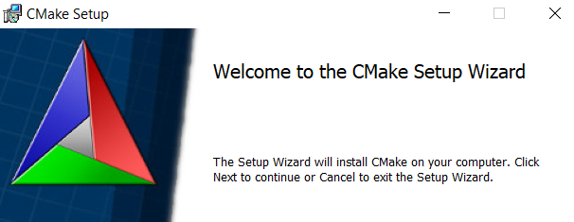

* Make sure to add the User path (as per instruction on the Box2D page)

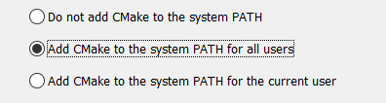

* Run the Build.bat (double-click) in the Box2D folder

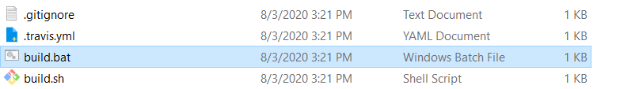

* This will launch Visual Studio with the Box2D solution
* Run the program

Play with the *testbed* and check out the different simulations that can be used with Box2D. A screenshot of the *testbed* running will be submitted for this assignment.

# 

# Change the Solution to x64

* Box2D only builds an x64 lib so our GAT150 Visual Studio Solution will need to be switched to x64

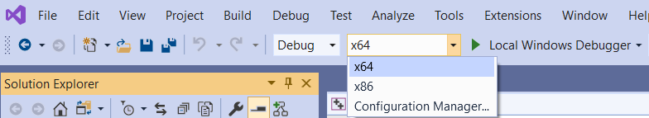

* The only other change that needs to be made is to add the x64 libs for SDL
  + Copy the .dll files from the SDL lib/x64 directory and overwrite the current ones in our build folder

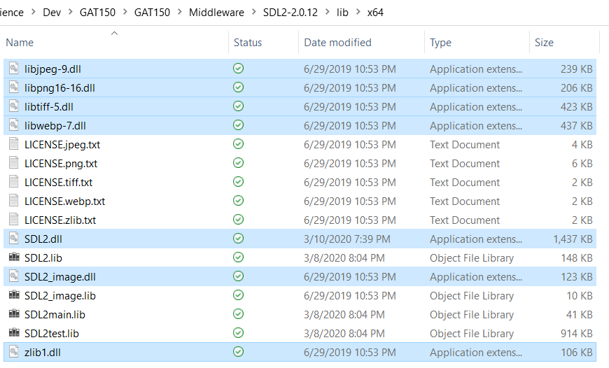 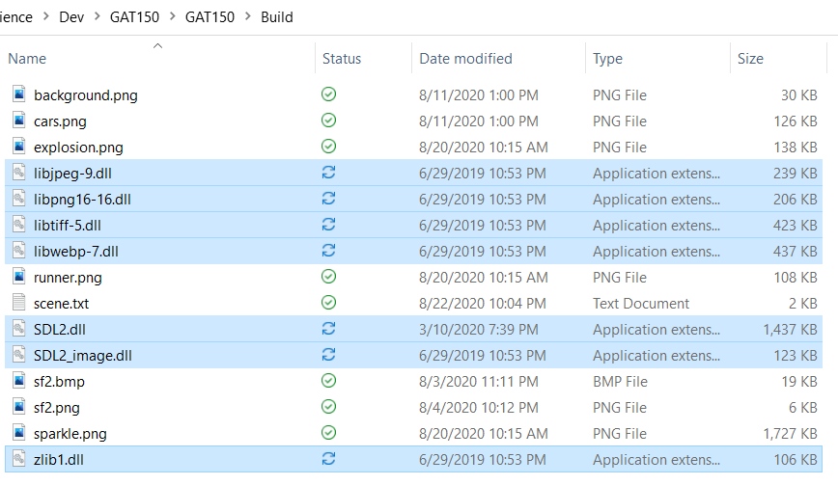

* Run the GAT150 program to make sure it works with the x64 build

# Add Box2D to the Engine Project

* Make a directory in the Middleware folder called ‘Box2D’

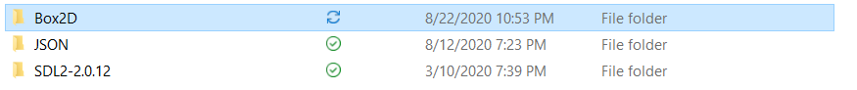

* + Copy the *include* folder from the unzipped and built *box2d-master* directory. This folder contains all the headers to use Box2D

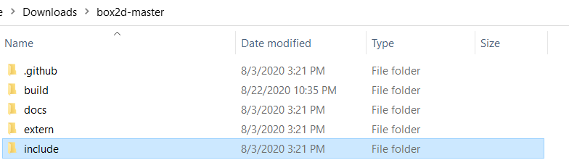

* + Place the *include* folder into the Middleware\Box2D folder

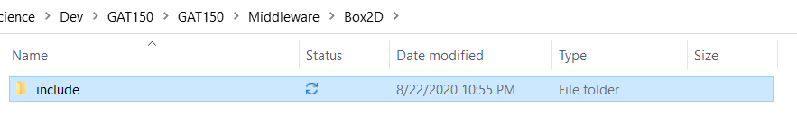

* Set the include directories for the *Engine* project to point to the Box2d folder
  + $(SolutionDir)\Middleware\Box2D

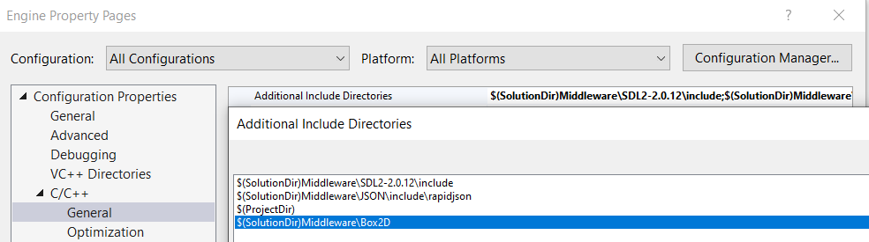

* + Copy the Box2D lib file into the *Middleware* Box2D directory
    - The lib file is located at: box2d-master\build\src\Debug

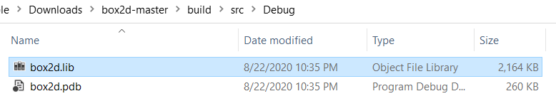

* + Create a directory called ‘lib’ in the *Middleware* Box2D directory

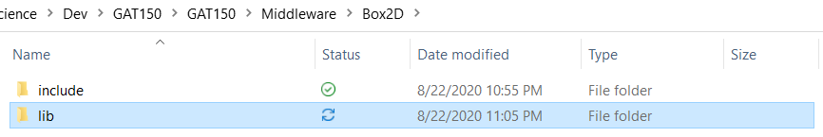

* + - * Copy the *box2d.lib* into the *lib* directory

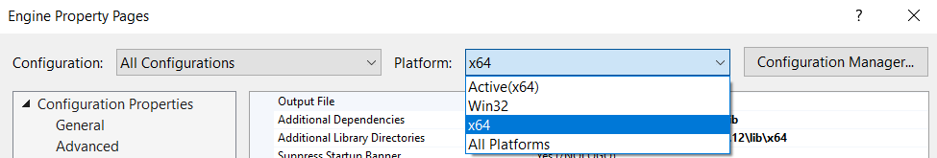

* Add the library (.lib) to the *Engine Project*
  + Open the *Engine Project* properties
  + Add *box2d.lib* to the *Librarian>General>Additional Dependencies*

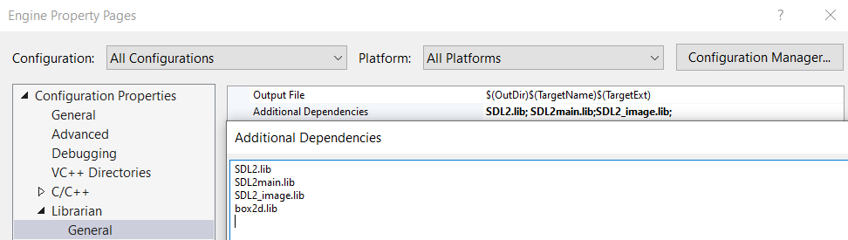

* Add the box2D library directory to the *Engine Project*
  + Set the Platform to *x64* for this step
  + Set the *Librarian>General>Additional Library Directories* for the *Engine* *Project* to point to the Box2D lib directory
    - $(SolutionDir)Middleware\Box2D\lib

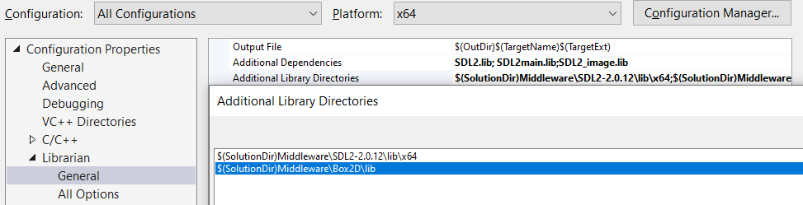

* + - Click Apply

Switch the *Platform* back to *All Platforms* in the *Engine Properties*

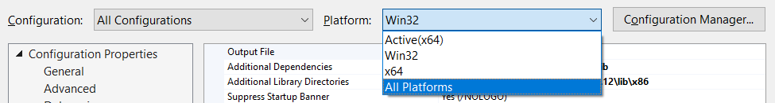

*Build and run the program to ensure it runs correctly. You will not see a change in the program execution at this stage*

This concludes the first portion of the physics assignment. Submit a screenshot of a Box2D demo running.

***REFERENCES***

Box2D:

<https://box2d.org/>

<https://box2d.org/documentation/>

GitHub:

<https://github.com/erincatto/box2d>